

**TALLINN UNIVERSITY OF TECHNOLOGY**

SCHOOL OF ENGINEERING

Laboratory of Wood Technology

**Materials Testing Methods**

**EKX0350**

***R coding practical work***

|  |  |
| --- | --- |
| Student: | Artjom Kotov |
|  |  |
|  |  |
| Supervisor: | Heikko Kallakas |
|  |  |

Tallinn 2025

1. **R coding task**
2. Install R software from here: <https://cran.rstudio.com/>
3. Install RStudio from here: <https://posit.co/download/rstudio-desktop/>
4. Open RStudio and import Excel file “Exercise.xlsx”
5. Make 4 different graphs in R:
   1. **Bar chart** – load the Barchart tab from the Excel file and make the 2 separate bar charts with error bars using the font Times New Roman.
   2. **Line Plot** – load the Line plot tab from the Excel file and make a line plot, where y = Brinell hardness (BH) and x = Surface roughness (Ra). Use font Times New Roman.
   3. **Boxplot** – load the Boxplot tab from the Excel file and make the 2 separate boxplots, where y = surface roughness (Ra) or Brinell hardness (BH), x = Wood samples, color = Samples. Use text font Calibri and theme black/white and remove any additional background.
   4. **Scatter plot** – load Scatter tab from the Excel file and make scatter plot, where y = Brinell hardness (BH), x = Density, color = Wood samples. Add error bars to Brinell hardness. Use text font Arial Unicode MS theme black/white and remove any additional background.
6. Make ANOVA and TUKEYHSD statistical analysis.
   1. Load R statistics tab from the Excel file and make the ANOVA analysis for Surface roughness and Brinell hardness values.
   2. After ANOVA test, make the TUKEYHSD test with confidence level of 95%.
   3. Great the groupings of TUKEHSD results
   4. Export the TUKEYHSD groups in Excel file
7. Add all graphs into this Word Template
8. Add ANOVA and TUKEYHSD groups into this Word Template.
9. **R plots**
10. Bar chart here / Line plot here / Boxplot here / Scatter plot here

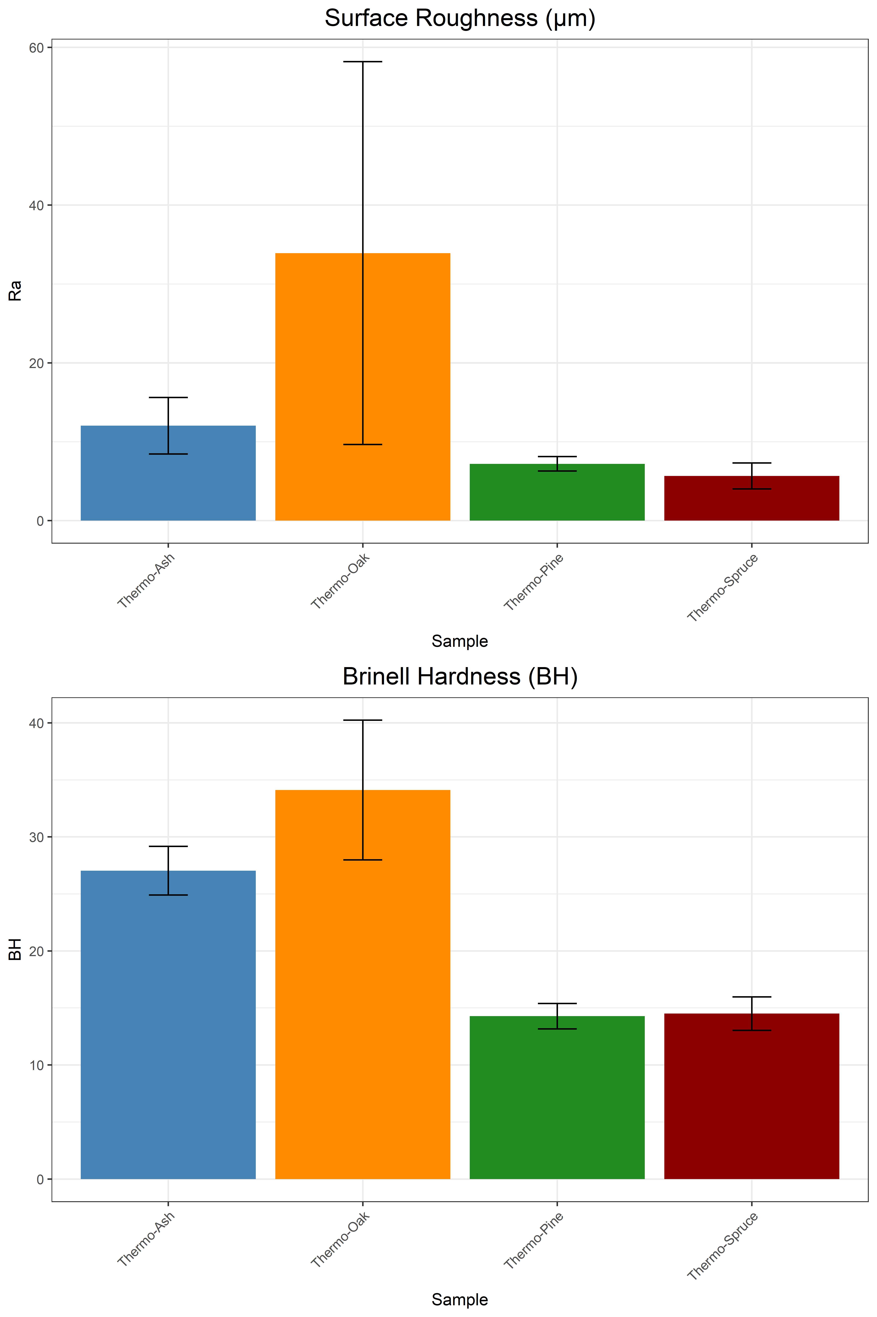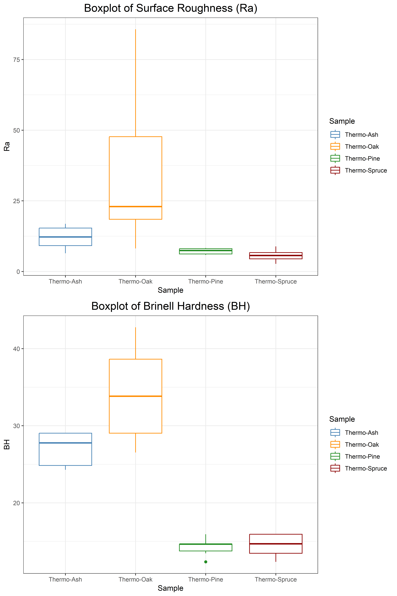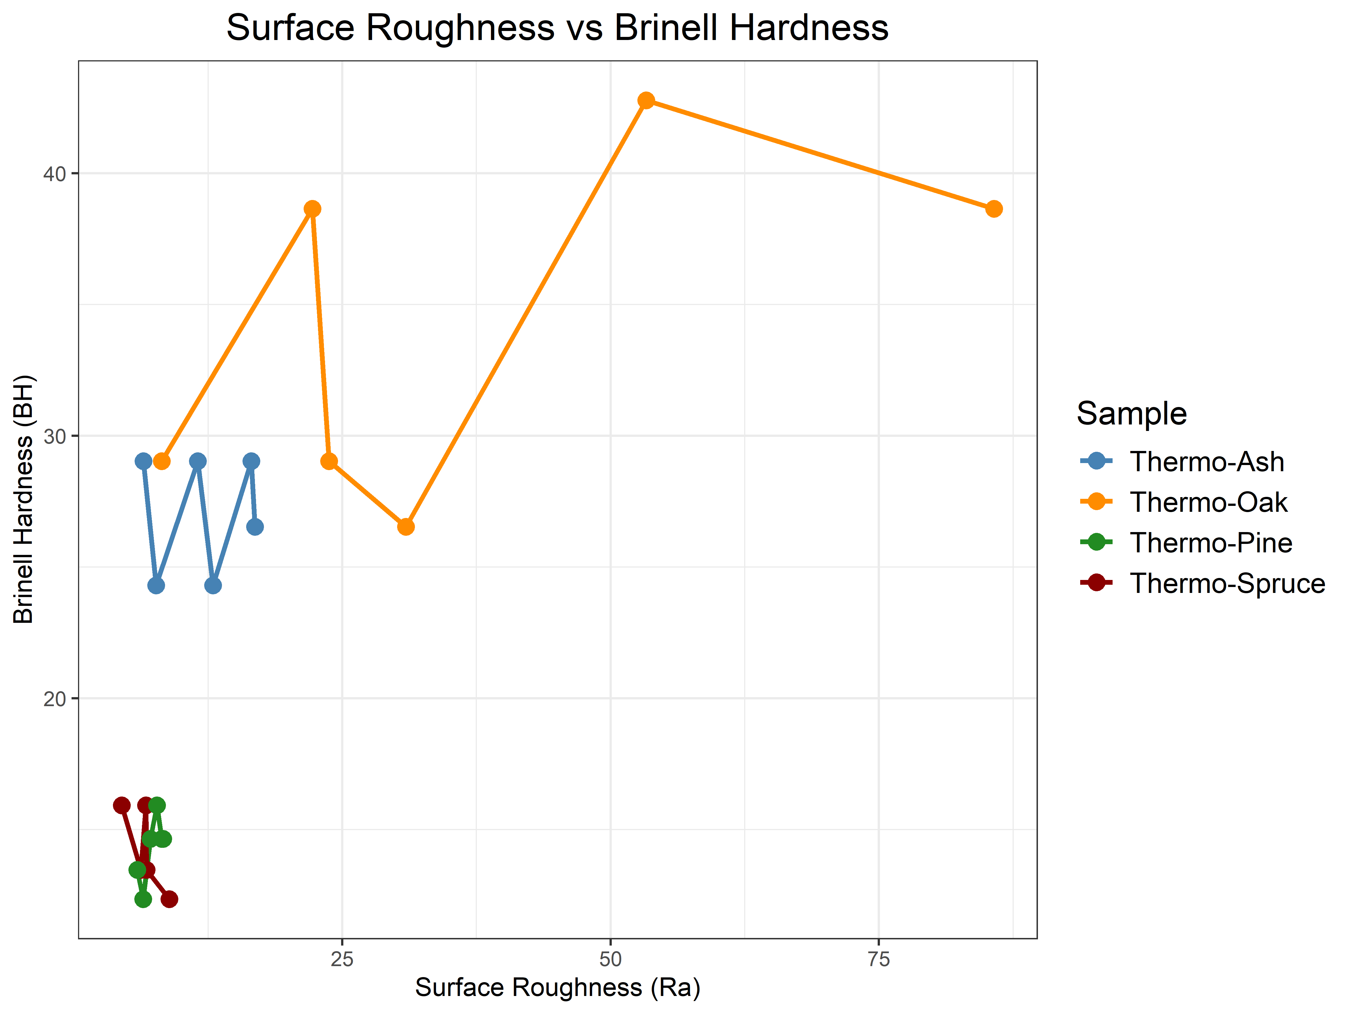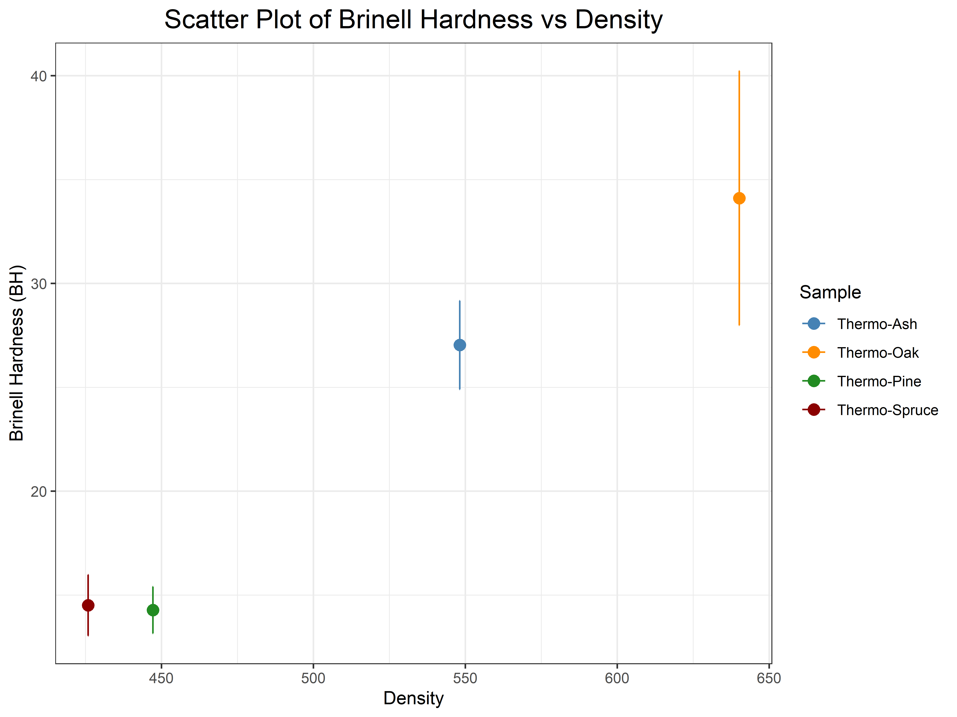

1. **R statistics**
2. ANOVA results here

|  |  |  |  |  |
| --- | --- | --- | --- | --- |
| Df | Sum Sq | Mean Sq | F value | Pr(>F) |
| 3 | 5147.0361556 | 1715.67871853333 | 10.1959717883506 | 5.31215967935664E-05 |
| 36 | 6057.7289884 | 168.270249677778 |  |  |

1. TUKEYHSD grouping here

|  |  |  |  |  |
| --- | --- | --- | --- | --- |
| diff | lwr | upr | p adj | Comparison |
| 21.8932 | 6.26922075080721 | 37.5171792491928 | 0.00311589010678537 | Thermo-Oak-Thermo-Ash |
| -4.8302 | -20.4541792491928 | 10.7937792491928 | 0.838611348255834 | Thermo-Pine-Thermo-Ash |
| -6.37379999999999 | -21.9977792491928 | 9.25017924919279 | 0.692591883281475 | Thermo-Spruce-Thermo-Ash |
| -26.7234 | -42.3473792491928 | -11.0994207508072 | 0.000279601342716318 | Thermo-Pine-Thermo-Oak |
| -28.267 | -43.8909792491928 | -12.6430207508072 | 0.00012593364329927 | Thermo-Spruce-Thermo-Oak |
| -1.54359999999999 | -17.1675792491928 | 14.0803792491928 | 0.993288872924178 | Thermo-Spruce-Thermo-Pine |